**Task 1: Create Three More Resource Groups in a Specific Region (West US)**

You can perform this task using both **Azure CLI** and **Azure PowerShell**.

**Using Azure CLI:**

1. Open the **Azure Cloud Shell** (you can use the Azure Portal or connect through your local Azure CLI).
2. Run the following commands to create three resource groups in the West US region:

**az group create --name rg-one --location westus**

**az group create --name rg-two --location westus**

**az group create --name rg-three --location westus**

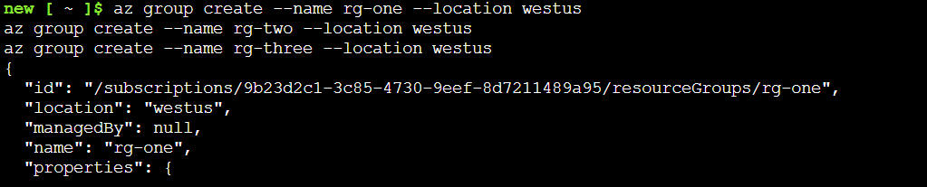

**Using Azure PowerShell:**

1. Run the following commands in **Azure Cloud Shell (PowerShell)** or through your local PowerShell terminal:

**New-AzResourceGroup -Name "** **rg-powershell-one" -Location "West US"**

**New-AzResourceGroup -Name "** **rg-powershell -two" -Location "West US"**

**New-AzResourceGroup -Name "** **rg-powershell -three" -Location "West US"**

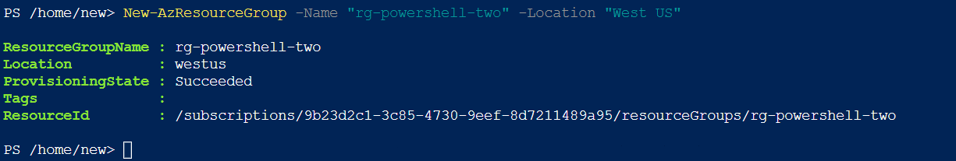

**Task 2: List All Resource Groups in West US**

**Using Azure PowerShell:**

To list all resource groups in **West US** using PowerShell, run:

**az group list --query "[?location=='westus']" --output table**

